Lopende Zaken Text report

You can use the template below here when preparing your test plan and you can send it filled in to the Logius Service Centre to be used when approving the connection of your organisation to Lopende Zaken

4.1 | Organisation data General  Test date: June 6, 2014
 | Organisation: Pink Roccade Local Government
Test report filled in by: Florin Cristian Moldovan
E-mail: florin.moldovan@tss-yonder.com
 | Phone number:+40 (0) 748 785 297

- The undersigned declares, in the name of the above organisation, that he has truthfully filled in the Lopende Zaken Testing report.

Signature: Florin Cristian Moldovan

Date: June 6, 2014

Checklist Test Lopende zaken

Nr | √ | Omschrijving | Explanation / Result
Opvragen accountstatus (Profielservice)
1 | □ | Send a request to the service profielService with a registered BSN at MijnOverheid.  Check if a response is received with the information that the BSN has an account at MijnOverheid. | Sent message:  Received message:
2 | □ | Send a request to the service profielService with a non-registered BSN at MijnOverheid.  Check if a response is received with the information that the BSN has no account at MijnOverheid. | Sent message:  Received message:
Aanleveren en weergave van zaakberichten
3* | □ | Starting a Zaak  Send a valid StUF-Zaak message with a new Zaak for a registered BSN to MijnOverheid.  Check if the Zaak is added in MijnOverheid and if this is presented properly with correct content at Lopende zaken. | Sent message:
4* | □ | Updating a Zaak  Send a valid StUF-Zaak message with an update for the Zaak of nr. 3 to MijnOverheid. The message has to contain an update of the element status.  Check if the Zaak in MijnOverheid is updated for the element status and if this is presented properly with correct content at Lopende zaken. | Sent message:
5* | □ | Closing a Zaak  Send a valid StUF-Zaak message with an update for the Zaak of nr. 3 to MijnOverheid. The message has to contain a filled element einddatum (enddate).  Check if the Zaak in MijnOverheid is updated for the element einddatum and if this is presented properly with correct content at Afgehandelde zaken. Afgehandelde (closed) zaken is e separate part of Lopende zaken. | Sent message:
6 | □ | Zaak message with error  Send a StUF-Zaak message to MijnOverheid with one of the following errors:  - Non-registered BSN  - Unknown sender  - Wrong OIN/HRN  - Invalid XML-structure | Our system cannot send incorrect messages because of the following reasons:  - Non-registered BSN – the system checks if the BSN inside of a case message is subscribed to Lopende Zaken using the Profile Service call (see steps 1 and 2). If the BSN is not registered, no request is sent to MijnOverheid  - Unknown sender – for the moment the value ‘CGS’ is hardcoded and will be always the value in element applicatie  - Wrong OIN/HRN – the value for the OIN is taken out of the CPA. Tempering with the OIN in the CPA makes our system throw an internal error. If this happens, no message is sent to MijnOverheid  - Invalid XML-structure – We already perform and XSD validation on the request message before sending it to MijnOverheid. If the validation fails, the message is never sent to MijnOverheid
Controleren zaakbericht verwerking
7 | □ | Check if at step 3, 4 en 5 no error messages are returned by MijnOverheid | Acknowledgement message is received from MijnOverheid  Note: Sending applications CZA and CGS both working
8 | □ | Check at step 6 if an error message is returned by MijnOverheid, with an errorcode that matches the error used at step 6 | Unable to receive error message – see step 6
* add screenshot (see next table)

Screenshots

Nr | Screenshot
3 | 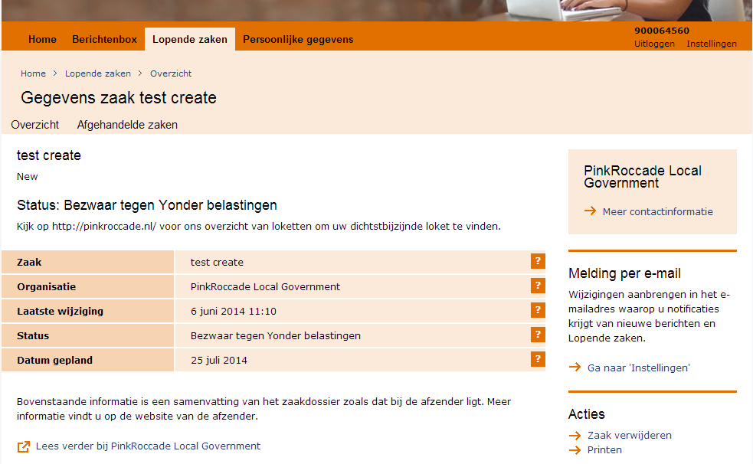
4 | 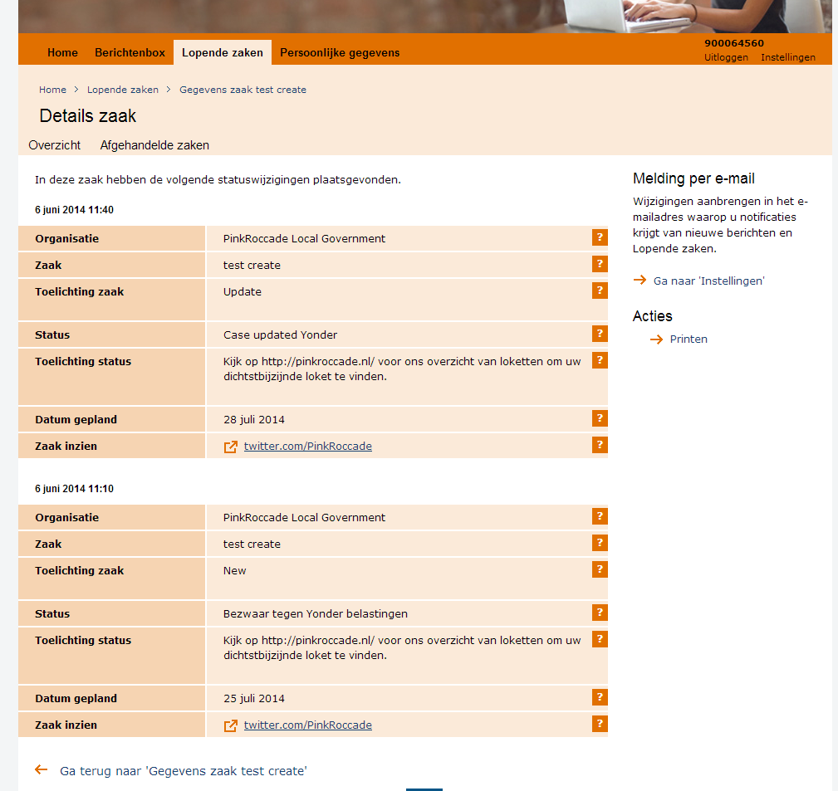
5 | 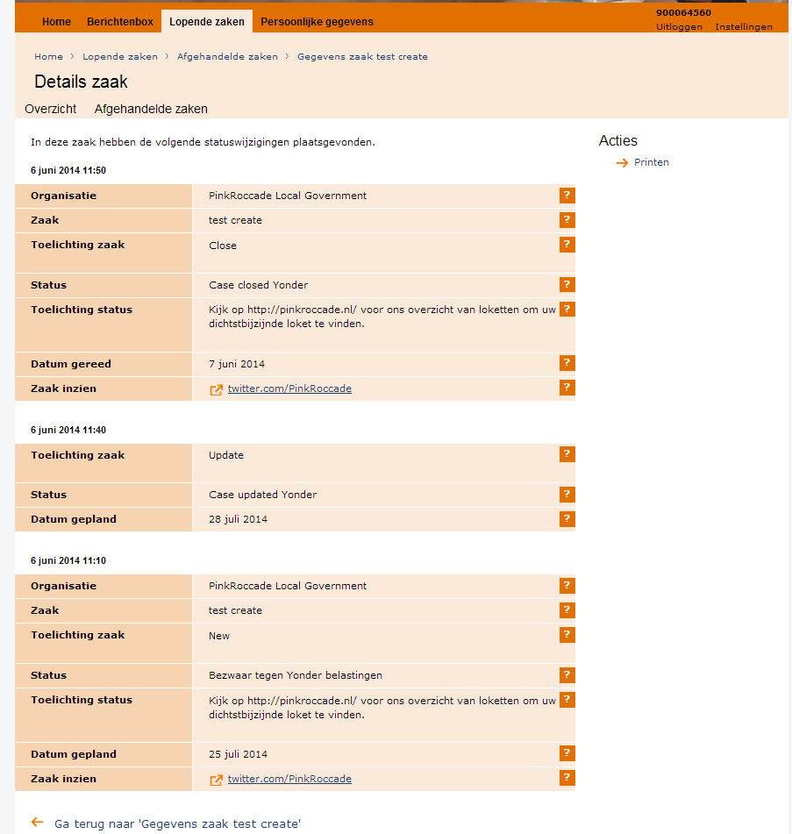
Second application CGS | 