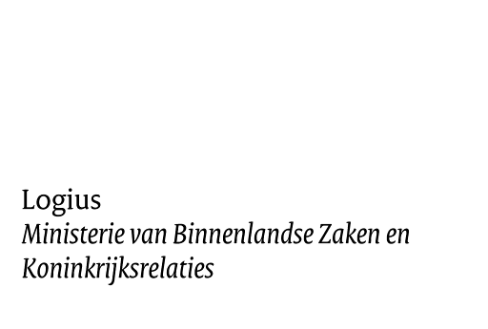

Checklist for testing the Inbox - MijnOverheid

Version 1.1

Date October 1, 2013
Status Definitive

Colofon

Project name MijnOverheid
Version number 1.1
Contact person Logius Service Centre Organisation Logius
Postbus 96810 2509 JE Den Haag
servicecentrum@logius.nl

Annex(es) 0

Document management

Date | Version | Author | Remarks
July 10th, 2012 | 1.0 | Logius | Initial version
October 1, 2013 | 1.1 | Logius | Title  improvements.

Introduction

This document describes how and what your organisation must test when it comes to the various connections that your organisation makes with the services of the Inbox.

For the last version of this document, other documentation of MijnOverheid and updated information, go to: www.logius.nl/mijnoverheid

Target group
This manual focuses:
    - government organisations that want to use the Inbox.
    - providers who want to realize a connection to the Inbox for and by order of government organisations.

Reader’s guide
This Checklist helps your organisation test the connections to the preproduction environment of the Inbox. It describes the test assignment, an approach and it contains a template for the test report that your organisation must submit to Logius.

Suggestions
Logius thinks its important that you can start using the Inbox of MijnOverheid fast and without any problems. This Checklist helps you to it. Do you have suggestions for improving this document further?
Then please send them to the Logius Service Centre.

Definitive | Checklist when Testing Inbox MijnOverheid | October 01, 2013

Overview of the MijnOverheid architecture

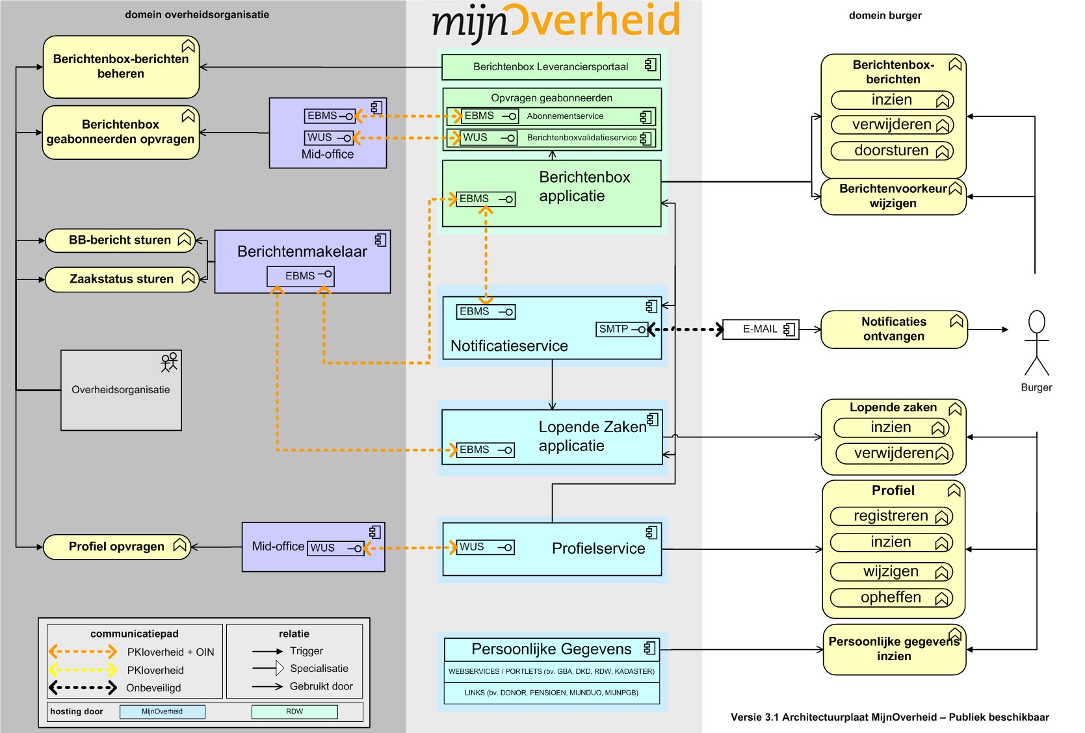

Figure 1: Overview of the MijnOverheid architecture

Page 5 of 14

Test assignment.

Your organisation must prove that they are able to send Inbox messages, of which the Message Type is included in the Provider Portal inbox, so that they are correctly shown to the citizen in MijnOverheid. In addition to that, your organisation must prove that they can query correctly the Subscription service and/or the Inbox validation service.

Test scope
The following connections and the belonging functionalities fall within the scope of the Inbox Checklist tests:

Connection with the Inbox Provider Portal;
Connection with the Subscription service and/or Inbox service; Connection with the Inbox for sending Inbox messages and for receiving results.

These are the direct connection points from the system of your organisation with the system of MijnOverheid, see Figure 1.

The testing of (direct or indirect) connections from your system/organisation that don’t occur in the list above (for example login with DigiD, register, receive the email notification from MijnOverheid) falls outside the scope of this checklist and, by that, outside the part about which your organisation must inform Logius. Of course, you can include such tests in your own (internal) test plan.

Necessary documentation and test basis
The contents of the following documentation must be known before starting to test:
Koppelvlakspecificaties Berichtenbox;
Handleiding Aansluiten Berichtenbox;
Handleiding Berichtenbox Leveranciersportaal.

Limiting conditions and starting points
Before starting this test, Step 2 from the Handleiding Aansluiten Berichtenbox (Manual Connecting to Inbox) must have been successfully performed. In short, this implies the following:

Your organisation has a PKIoverheid-certificate including OIN or HRN (in case of supplier connection);
The system of your organisation is set up and is able to generate Inbox messages, the internal acceptance was completed successfully and there are no unsolved blocking findings;
Your system has a functional network connection to the preproduction environment of MijnOverheid;
Your system is connected to the preproduction environment of MijnOverheid by using the Digikoppeling (ebMS and/or WUS);
From your organisation, the Inbox Provider Portal (Leveranciersportaal) (preproduction) can be accessed by using the received certificate.

Your organisation has the Inbox Provider Portal (preproduction) set up.
Your organisation has (at least two) test-DigiD-accounts with the belonging test-CSNs.

Test approach

The test approach for testing connections and functionalities in a structured way has a number of phases:

- Preparation:
- Execution
- Round off.

Preparation
During the preparation phase, those activities are performed that enable you to perform all the tests in a small amount of time and to obtain the results.

    - Setting up Inbox Provider Portal
Before starting the chain test, by using the Berichtenbox Leveranciersportaal (preproduction) it is important to create the message type(s) that will be used at the test.

Pay attention!
The message type(s) must also be activated! For more information, see:
Handleiding Berichtenbox Leveranciersportaal. (Inbox Provider Portal Manual)

In addition to that, the profile data (description) of your organisation must be filled out in the Inbox Provider Portal (preproduction), see the Handleiding Berichtenbox Leveranciersportaal for this.

    - Register test CSNs at MijnOverheid preproduction
Log in with the test DigiD-accounts to the preproduction environment citizen portal of MijnOverheid (https://toets.mijnoverheid.nl) to register accounts. This way, the test CSNs are loaded in the system and messages can be sent to these CSNs or their status can be inquired.
Create at least two MijnOverheid-accounts, one with the message preference for your organisation enabled and one with the message preference for your organisation disabled. You can do this as follows: log on with the test DigiD-accounts to the preproduction environment of MijnOverheid, open Mijn account and select ‘Organisaties Berichtenbox’, you see here your organisation data. Check directly if these data are correct. After that, you can enable or disable the preference.

    - Preparing testdata
Make sure that all test data are known and available and can be delivered at the Inbox. For all the test that must be performed, test data are necessary. Make sure that you have all the complete data, see the template in this document for the minimum requirements. Also see the Koppelvlakspecificaties Berichtenbox (Interface specifications Inbox). Aside from the test data, you must also configure and prepare systems to generate and deliver test data.

    - Plan in testing
We recommend you to test the network overview made in Step 2 of the Handleiding Aansluiten Berichtenbox (Manually Connecting to Inbox), if the test setup and the

contact data of the management organisations involved are displayed correctly. You can also briefly check the connections, as described in paragraph 4.3.9 in the Handleiding Aansluiten Berichtenbox.
When your organisation is ready with the preparation, you can contact the Logius Service Centre to synchronize the period in which testing will take place.

Execution
When the preparation activities are performed, you can start performing the tests. For the contents of the tests, aside from your own test scenarios, see the template from chapter 4.

If, while testing, you run into availability problems of the preproduction environment of MijnOverheid, then contact the Logius Service Centre.

Round off.
After completing the planned tests and drawing up the test reports, Logius recommends you to keep testware (test messages, test tooling etc.).

Make sure that all acceptants have accepted the test reports before sharing the results with Logius.

If Logius has approved your test report, then the connection to Preproduction is successfully completed. Your organisation can start with the connection to production.

4 Template: Inbox Text report

You can use the template below here when preparing your test plan and you can send it filled in to the Logius Service Centre to be used when approving the connection of your organisation to the Inbox (Berichtenbox).

4.1 | Organisation data General  Test date: | Pink Roccade Local Government
 | Organisation:
 | Test report filled in by: E-mail: | Popa Ionut Alexandru  ionut.popa@tss-yonder.com
 | Phone number: | +40 (0) 751 020 483

- The undersigned declares, in the name of the above organisation, that he has truthfully filled in the Inbox Testing report.

Signature: Popa Ionut-Alexandru

Date: 26.09.2014

Connection

Query subscribers, connected to (check at least one):

- Subscription service (Abonnementservice) x Inbox validation service
- OIN: 00000001819697461000

Checklist for testing the Inbox
Starting point: user A has enabled the message preference for your organisation, user B has disabled the message preference for your organisation. For components provided with an *, you must add a screenshot. In what component 3 is concerned; depending on your selection, you test the service that you implemented.

No | √ | Description | Explanation / Result
 |  | Setting up Inbox Provider Portal
1* | □ | Introduce profile data (description) of your organisation.  By using the preproduction environment citizen portal of MijnOverheid, check whether they are displayed correctly.
2* | □ | Create message type(s) for use by the test.
 |  | Test query subscribers (fill in at least one)
3a | □ | Query the Subscription service (Abonnementservice) (if connected) for citizens with the message preference enabled for your organisation.  Check if user A is displayed and user B  isn’t displayed in the answer message.
3b | □ | Query the Inbox validation service (if connected) for citizens with the message preference enabled for your organisation.  Check if user A is displayed and user B isn’t displayed in the answer message.
 |  | Send Inbox messages:
4 | □ | Batch 1: send Message batch with 1 message for  user A.
5 | □ | Batch 2: send Message batch with 1 message for  user A and 1 message for user B.
 |  | Check message processing
6 | □ | Check results return message (ebMS).  Batch 1: 1 message correctly processed.  Batch 2: 1 message correctly processed, 1 message rejected because ‘no active box or no active preference’. | The checkbox for Pick Roccade was unchecked on 22 September for user B (900080917). The message that was sent to him was succesfully processed and it appears in section BerichtenBox.
7* | □ | Check results in Inbox Provider Portal.  Batch 1: 1 message correctly processed.  Batch 2: 1 message correctly processed, 1 message rejected because ‘no active box or no active preference’.

 |  | Check message display
8* | □ | By using the preproduction environment citizen portal of MijnOverheid, check whether the Inbox messages are displayed correctly.  Log in with:  User A: has 2 messages.  User B: doesn’t have any messages.  Messages are displayed correctly (subject, message body and name of the attachment to be downloaded). | User A (900080905) has 2 messages (Message A and Message B and A); User B (900080917) has one message (Message B and A) doue to the explanation I have made on subsection 6.  Subject, message body and name of the attachement are displayed correctly. Attachement can be downloaded.
9 | □ | By using the Inbox at the preproduction environment citizen portal of MijnOverheid, open the attachments for user A.  The attachments are identical to the sent attachments. | The message attachements are identical to the ones sent.  The original was:
10 | □ | Check whether the attachments comply with the web guidelines  regarding PDF/A or PDF/X compliance.1
* add screenshot (see table paragraph 4.3)

Screenshots
Insert below here the results of the tests above, in which this is indicated.

No | Screenshot
1 | [insert screenshot]
2 | [insert screenshot]
7 | [insert screenshot]
8 | 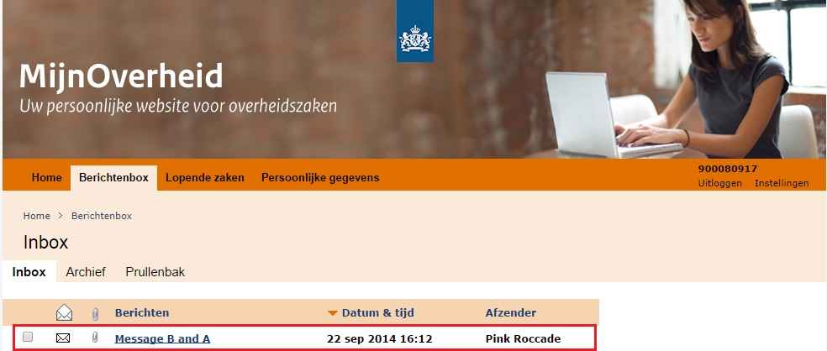  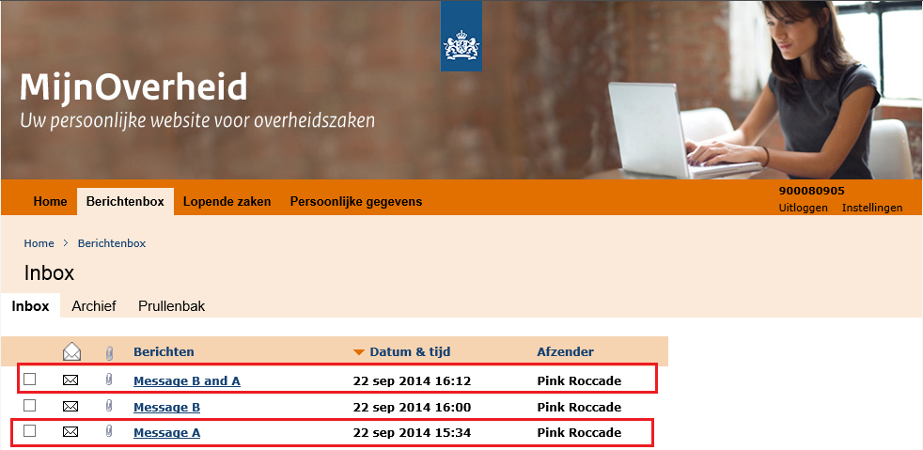

1 When opening a document in Adobe Reader (version 9 or higher), the reader indicates whether the document is PDF/A compliant. In addition to that, you can use an online compliance check: http://www.validatepdfa.com/

Limited production run

The limited production run is the first usage of the new connections in production. Logius commits you to perform a limited production test before your organisation introduces the channel Inbox completely for communication with the citizen. In this limited production run, all the connections made must be checked and the whole chain must be gone through from the user perspective (registration, login, view message, etc.).

For de LPR, your organisation itself selects a number of parties involved in the connection project. In the production run, inboxes of the involved parties are used and one or several messages are placed in them to check the chain. Aside from sending messages and from checking the final display in the Inbox of the citizen, you must also check the functions for querying the subscriber in the LPR.

Therefore, your organisation must be able to send its production messages to a small selected group. Maybe the line-responsible must be contacted for this, for sending this first series of production messages and their content.

If you find a problem when performing the LPR, then inform Logius about it via the Service Centre, so that the connection can possibly be undone.

For the LPR, Logius recommends to perform the tests 3 up to and including 9 from the template, supplemented by the check of the email notification receipt. Maybe the registration process can also be included. Check at the LPR whether everything - the information about your organisation and the messages that you sent - is displayed in MijnOverheid correctly and as you intended it to be displayed. You indicate at the Logius Service Centre that the production messages were successfully sent and send the test findings according to the template.

Contact data

If you want more information about the Inbox Test Plan, then contact the Logius Service Centre.

Telephone:
0900 555 4555 (10 ct p/m) in the working days between 08.00 - 17.00 o’clock.

E-mail: servicecentrum@logius.nl
Internet: www.logius.nl

Postal address: Postbus 96810 2509 JE Den Haag

